

Topic test 2
Name: __________________________________

Chapter 1: Three-dimensional vectors

- Time allowed: 45 minutes
- CAS calculators may be used.
- Part A: 5 multiple-choice questions (5 marks).
- Part B: 6 short-answer questions (45 marks).
- Part C: 2 analysis questions (10 marks).
Part A
Multiple-choice questions
5 multiple-choice questions
1 mark each: 5 marks
Circle the correct answer.
1 M(4, −1, −7) and which of the following points are on a line parallel with the x-axis?
A (−4, −1, −7)
B (3, −1, 7)
C (−4, 1, −7)
D (4, −1, 5)
E (4, 2, −7)
[1 mark]
2 The distance between A(p, q, r) and B(p, s, r) is:
A |r − p|
B |q − p|
C |s − q|
D |s − r|
E |p − q|
[1 mark]

Use the diagram below to answer Questions 3–5.
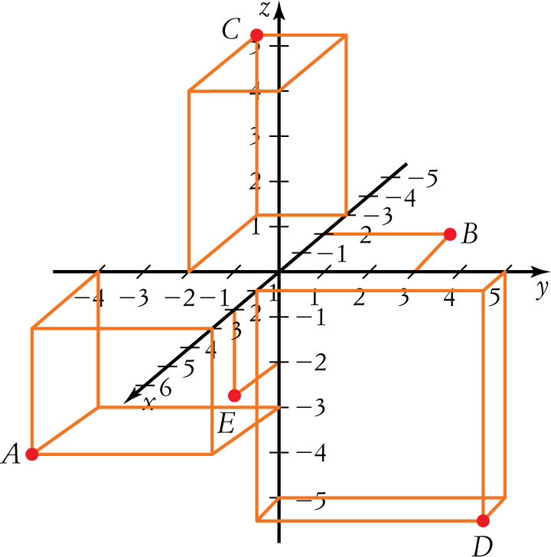
3 The point lying on the xy-plane is:
A A
B B
C C
D D
E E
[1 mark]
4 The point E is best described as lying on the:
A yz-plane
B y-plane
C xz-plane
D x-plane
E xy-plane
[1 mark]
5 The distance from the origin to A is closest to:
A 3
B 5
C 4
D 6
E 10
[1 mark]

Part B
Short-answer questions
6 short-answer questions
45 marks
Show your working where appropriate.
1 Find the radius and centre of the sphere
x2 + y2 + z2 − 14x + 4y − 12z + 25 = 0
[6 marks]
2 Given a = (−1, 3, 4), b = (5, −2, 6), and P = (4, 3, −7) and Q = (−3, −1, 4):
a find −2a + 5b
b show that (a − b) is parallel to (b − a)
c find PQ and |PQ|
d find
[10 marks]
3 a Show that the vectors (−2, −5, 6) and (−1, 4, 3) are perpendicular.
b Find the projection of a = (−4, 2, −3) on b = (2, −5, 1)
c Find the angle between p = 3i + 2j − 5k and q = 2i − 6j − 7k.
[10 marks]
4 a Find the vector product of vectors of magnitudes 24 and 17 if the angle between them is 428.
b Find the vector product of u = (7, −3, 2) and v = (−5, 4, −6).
[7 marks]
5 a Find the Cartesian form of the equation of the straight line which passes through the points (3, 7,−2) and
(4, 5, −3).
b Calculate the equivalent vector equation for the line.
[6 marks]
6 Find the equation of the plane that contains the points P(4, −3, 1), Q(5, 3, 2) and R(−6, 2, 5).
[6 marks]

Part C
Analysis questions
2 analysis questions
10 marks
Show your working where appropriate.
1 Given a quadrilateral with opposite sides parallel and equal, prove that the quadrilateral is a parallelogram.
[5 marks]
2 Find an equation for the plane consisting of all points that are equidistant from P(−1, 2, −3) and
Q(4, −2, 2).
[5 marks]
[ Total marks: 60]

Answers
Part A – Multiple-choice questions [1 mark each]
1 Points on a line parallel to the x-axis will have y- and z-coordinates the same but different x-coordinates.
 A [1 mark]
2 A and B have different y-coordinates but the x- and z-coordinates are the same.
The points are on a line parallel to the y-axis.
The distance between A and B will be the absolute value of the difference between the y-coordinates i.e. |s − q|
 C [1 mark]
3 Any point on the xy-plane will have a z-coordinate of 0.
B = (−2, 3, 0).
 B [1 mark]
4 E = (3, 0, −2).
The y-coordinate is 0, E lies on the xz-plane.
 C [1 mark]
5 Distance from the origin to A = 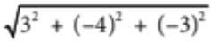  5.83  6
 D [1 mark]
Part B – Short-answer questions
1 x2 + y2 + z2 − 14x + 4y − 12z + 25 = 0
x2 + y2 + z2 − 14x + 4y − 12z = −25
(x2 − 14x) + (y2 + 4y) + (z2 − 12z) = −25 [1 mark]
(x2 − 14x + 49) + (y2 + 4y + 4) + (z2 − 12z + 36) = 49 + 4 + 36 − 25 [1 mark]
Factorise the squares. (x − 7)2 + (y + 2)2 + (z − 6)2 = 64 [1 mark]
(x − 7)2 + (y + 2)2 + (z − 6)2 = 82 [1 mark]
Compare with (x − h)2 + (y − k)2 + (z − l)2 = r2
Centre = (7, −2, 6) [1 mark]
Radius = 8 [1 mark]
[6 marks altogether]
2 a −2a + 5b = −2(−1, 3, 4) + 5 (5, −2, 6) [1 mark]
= (2, −6, −8) + (25, −10, 30)
= (27, −16, 22) [1 mark]

b a − b = (−1, 3, 4) − (5, −2, 6)
= (−6, 5, −2) [1 mark]
b − a = (5, −2, 6) − (−1, 3, 4)
= (6, −5, 2)
= −1(−6, 5, −2) [1 mark]
= −1(a − b)
(a − b) is parallel to (b − a) [1 mark]
c PQ = (x2 − x1, y2 − y1, z2 − z1)
= (−3 − 4, −1 − 3, 4 − −7)
= (−7, −4, 11) [1 mark]
|PQ| = 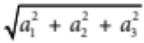
= 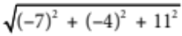
= 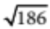 [1 mark]
d = 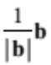 [1 mark]
= 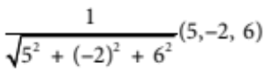 [1 mark]
= 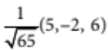
= 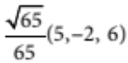 [1 mark]
[10 marks altogether]
3 a (−2, −5, 6) . (−1, 4, 3) = 2 − 20 + 18
= 0 [1 mark]
Since the scalar product is zero, the vectors are perpendicular. [1 mark]
b p_{b} a = a . [1 mark]
=
= 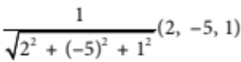
= 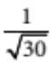 (2, −5, 1) [1 mark]
p_{b} a = (−4, 2, −3) . (2, −5, 1)
= (−8 − 10 − 3) [1 mark]
= 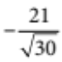 ≈ −3.8 [1 mark]
c cos(θ) = 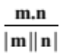 [1 mark]
= 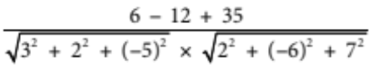 [1 mark]
= 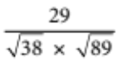
= 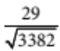 [1 mark]
θ ≈ 60.1 [1 mark]
[10 marks altogether]
4 a |v| = |v1| |v2| sin(θ) [1 mark]
= 24 × 17 × sin(42) [1 mark]
 273 [1 mark]
The vector product is about 273 in a direction perpendicular to the plane of the original vectors.
[1 mark]
b u = 7i − 3j + 2k, v = −5i + 4j − 6k [1 mark]
u × v = (−3 × −6 − 2 × 4)i − (7 × −6 − 2 × −5)j + (7 × 4 − −3 × −5)k [1 mark]
= 10i + 32j + 13k
= (10, 32, 13) [1 mark]
[7 marks altogether]
5 a Let A(a1, a2, a3) = (3, 7,−2)
and B(b1, b2, b3) = (4, 5,−3) [1 mark]
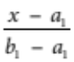 = 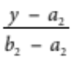= 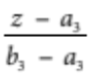
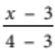 = 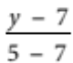 = 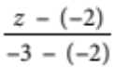 [1 mark]
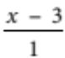= 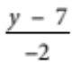 = 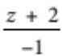 [1 mark]
b Compare = = with 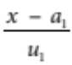 = 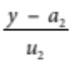 = 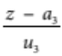
a1 = 3, a2 = 7, a3 = −2
and u1 = 1, u2 = −2, u3 = −1 [1 mark]
p = a + tu
= a1i + a2j + a3k+ t(u1i + u2j + u3k) [1 mark]
p = 3i + 7j − 2k + t(i − 2j − k) [1 mark]
[6 marks altogether]
6 PR = (−6 − 4, 2 − (−3), 5 − 1) = (−10, 5, 4)
PQ = (5 − 4, 3 − (−3), 2 − 1) = (1, 6, 1) [1 mark]
PR × PQ is normal to the plane containing PR and PQ [1 mark]
PR × PQ = (5 × 1 − 4 × 6)i − (−10 × 1 − 4 × 1)j + (−10 × 6 − 5 × 1)k
= −19i + 14j − 65k = n [1 mark]
Cartesian equation of the plane is: a1(x − x1) + a2(y − y1) + a3(z − z1) = 0
Let P(4, −3, 1), and n = (−19, 14, −65) [1 mark]
−19(x − 4) + 14(y + 3) − 65(z − 1) = 0 [1 mark]
−19x + 76 + 14y + 42 − 65z + 65 = 0
−19x + 14y − 65z + 183 = 0 is the equation of the plane [1 mark]
[6 marks altogether]
Part C – Analysis questions
1 Draw a sketch and label the vertices A, B, C and D.
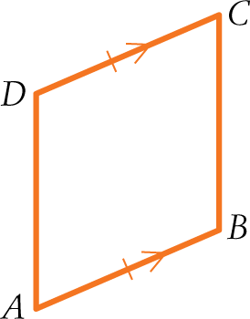
|AB| = |CD| (Given)
AB || CD (Given) [1 mark]
Thus AB = CD [1 mark]
b − a = d − c [1 mark]
Rearrange: d − a = c − b
AD = BC [1 mark]
ABCD is a parallelogram. [1 mark]
[5 marks altogether]
2 The midpoint of P and Q lies on the plane. [1 mark]
Midpoint of P and Q = [(−1, 2, −3) + (4, −2, 2)]
= (3, 0, −1) [1 mark]
A normal vector to the plane is given by QP
i.e. 4i − 2j + 2k − (−i + 2j − 3k)
= 5i − 4j + 5k [1 mark]
Hence, an equation of the plane is given by:
5 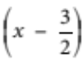 − 4(y − 0) + 5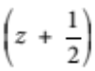 = 0 [1 mark]
5x − 4y + 5z − 5 = 0 [1 mark]
[5 marks altogether]

